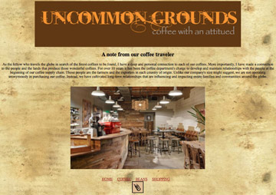
Uncommon Grounds-Image and linking demo exercise.
The Goal of this exercise is to create a four page site and upload in your webspace. I will check-off at the end of the day.

Navigation Bar:
HOME COFFEE BEANS SHOPPING and image below for contact that links to e-mail address

index.html page text

(note: create a banner for the top of the page about 900 px x 200 px)

A note from our coffee traveler

As the fellow who travels the globe in search of the finest coffees to be found, I have a deep and personal connection to each of our coffees. More importantly, I have made a connection to the people and the lands that produce those wonderful coffees. For over 10 years it has been the coffee department's charge to develop and maintain relationships with the people at the beginning of our coffee supply chain. Those people are the farmers and the exporters in each country of origin. Unlike our company's size might suggest, we are not operating anonymously in purchasing our coffee. Instead, we have cultivated long-term relationships that are influencing and impacting entire families and communities around the globe.

coffee.html

We Serve Only Fair Trade Coffee

A number of community-based programs in coffee-growing countries directly benefit from the purchase of our coffee. For example, farmers in Peru and Mexico receive a higher price per pound for their coffee (above and beyond the going rate for certified coffee) to help support local domestic violence intervention programs and small business loans for women

beans.html

We have a range of coffees to match your mood.

At Uncommon Grounds, we don't subscribe to a "one-roast-fits-all" policy. To achieve optimum coffee flavor, we roast each of our coffees at slightly different roast degrees to bring out each bean's full potential. You'll immediately taste the difference. Light roasts are livelier, laced with subtleties and sweet nuances. Darker roasts are rich and velvety, grounded in heavier tones and smoky hints.

Our coffees are arranged in order of roast degree.

Kenya-Sweet, blackberry, crisp, clean
Daybreak Morning Blend-Sweet, fruity, nutty
Guatemala El Socorro-Caramel, jasmine, fruity
Colombia-Smooth, sweet, caramel, nutty
Costa Rica-Chocolate, cherry, bold
More info if you are really enjoying this exercise! find your own pictures!

shopping.html page text

Get Uncommon Grounds Coffee and Equipment shipped right to your front door every month. Frothy Coffee will help you make your next occasion a little more special.
Office Coffee Delivery

Equipment
Brewers
French Press
Grinders

contact
commongrounds@comcast.net

